Student: Gourik Narendra Patil
Assigned incident: D3-C
GitHub branch: day-3-beyond-localhost

E1
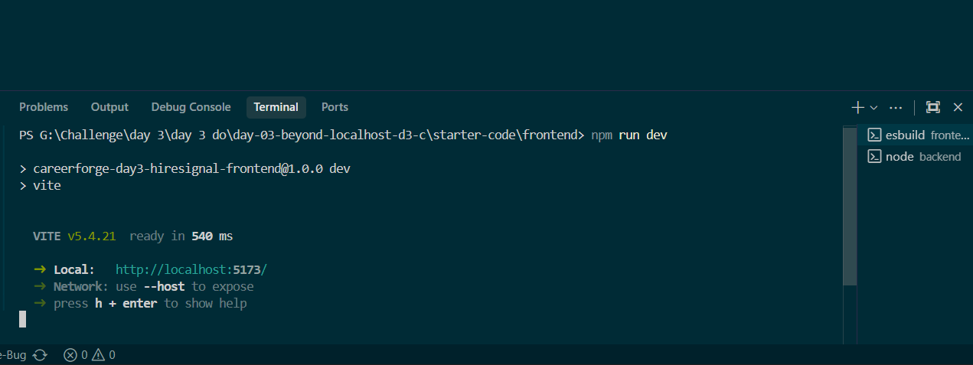
E2
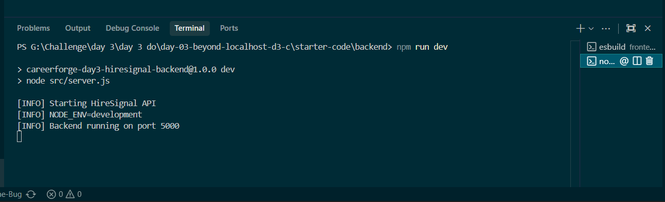

E3
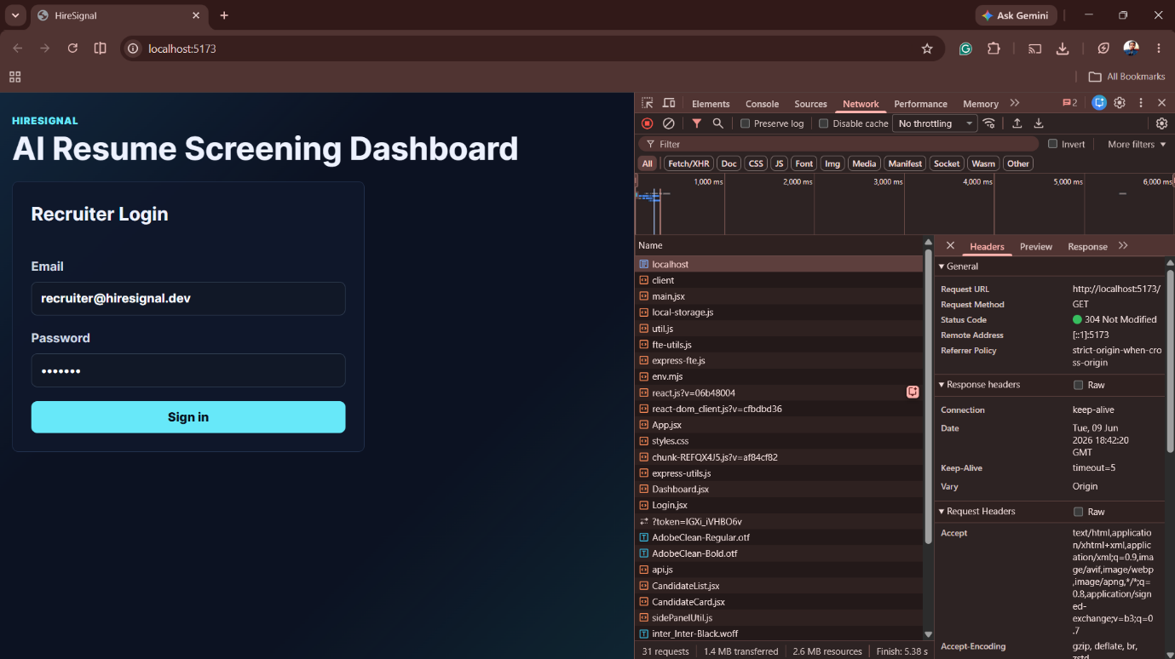

E4

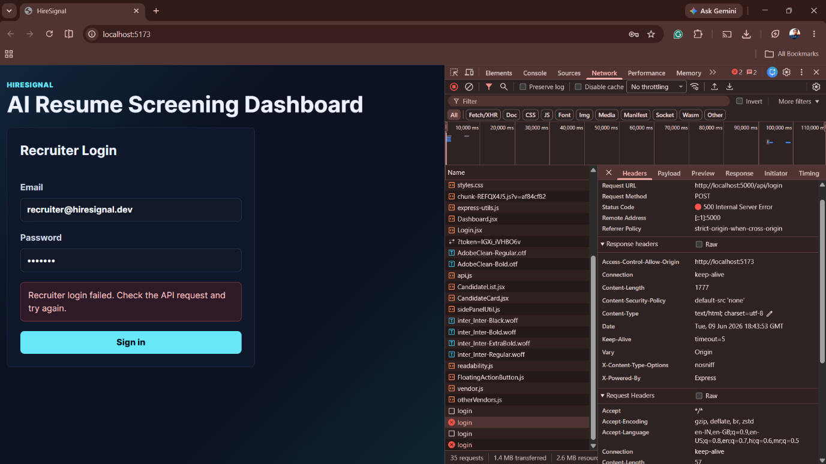

E5

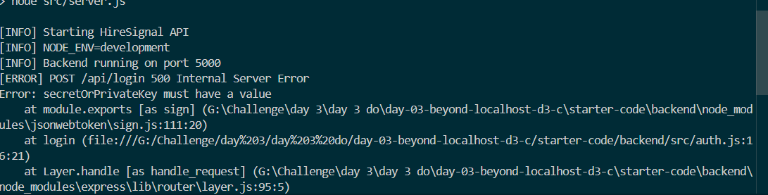

E6

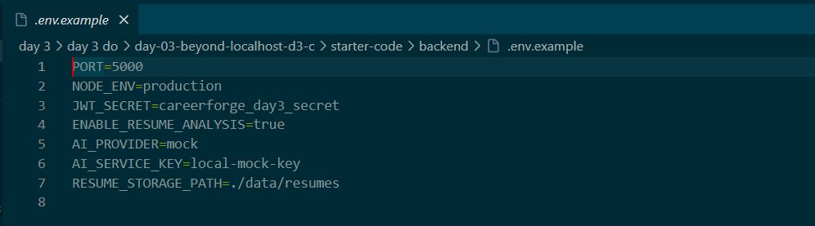

E7

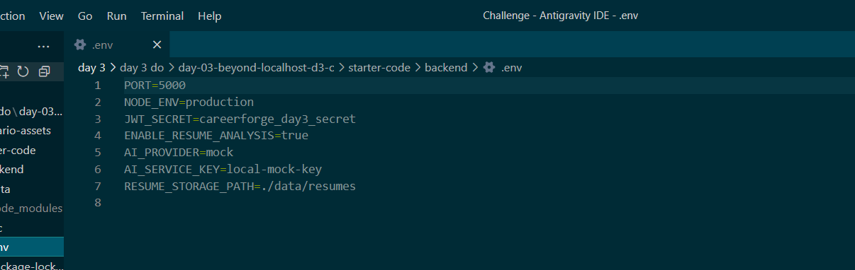

E8

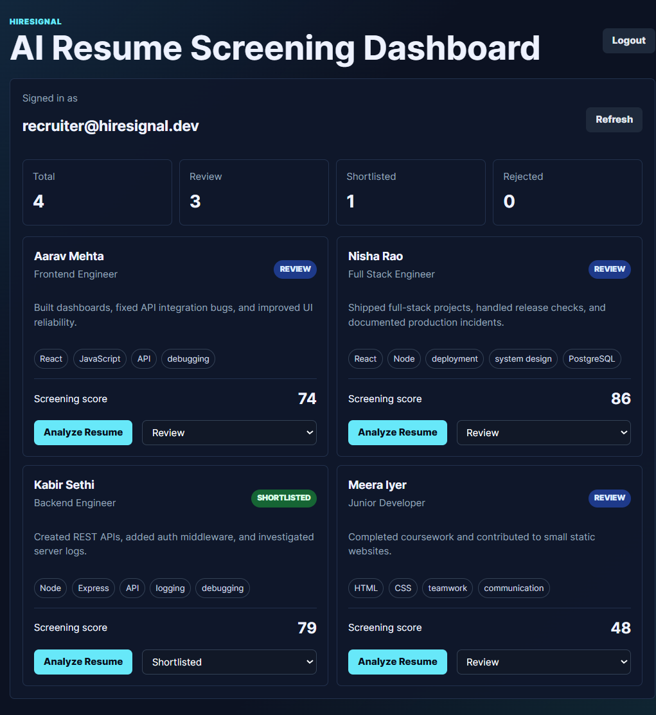

E9

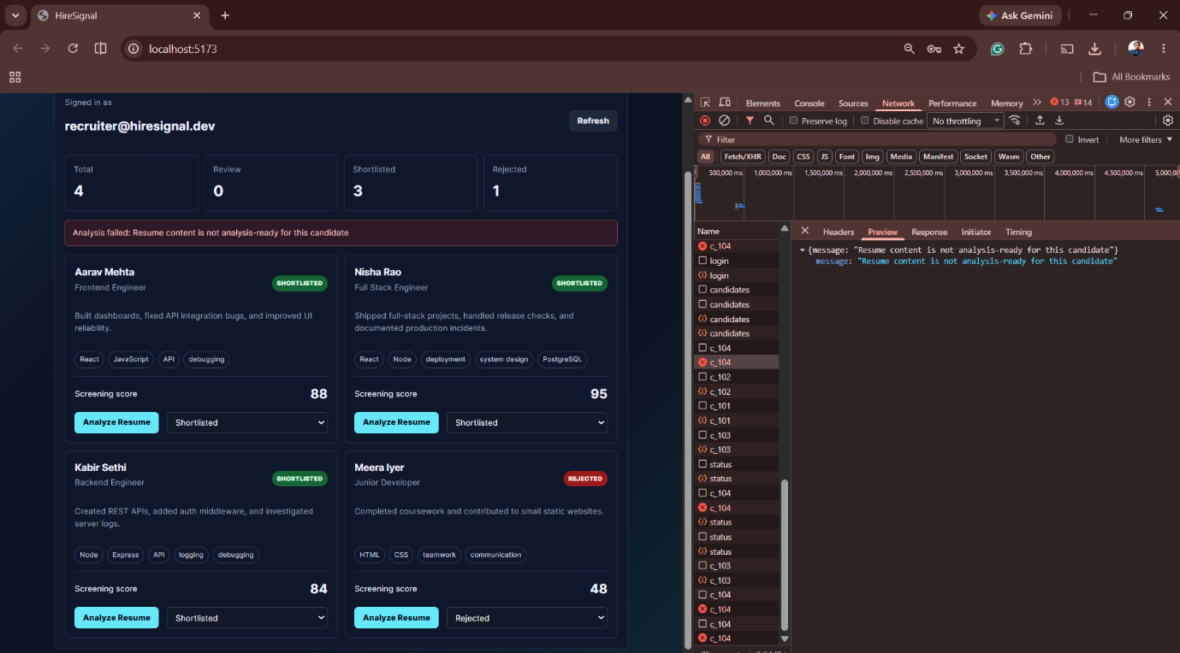

E10

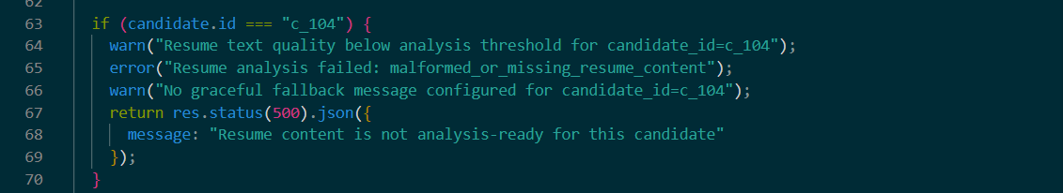

E11

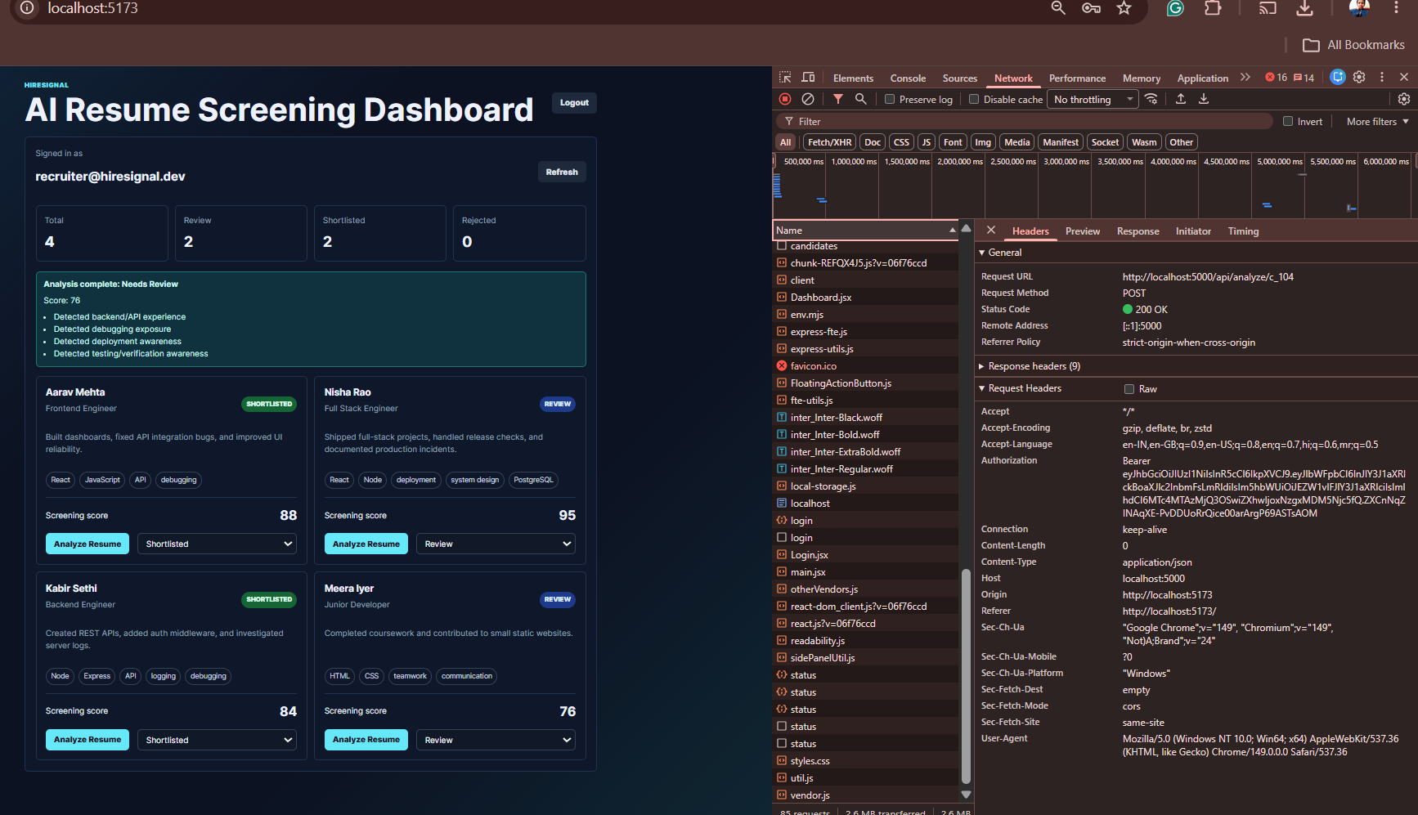

E12

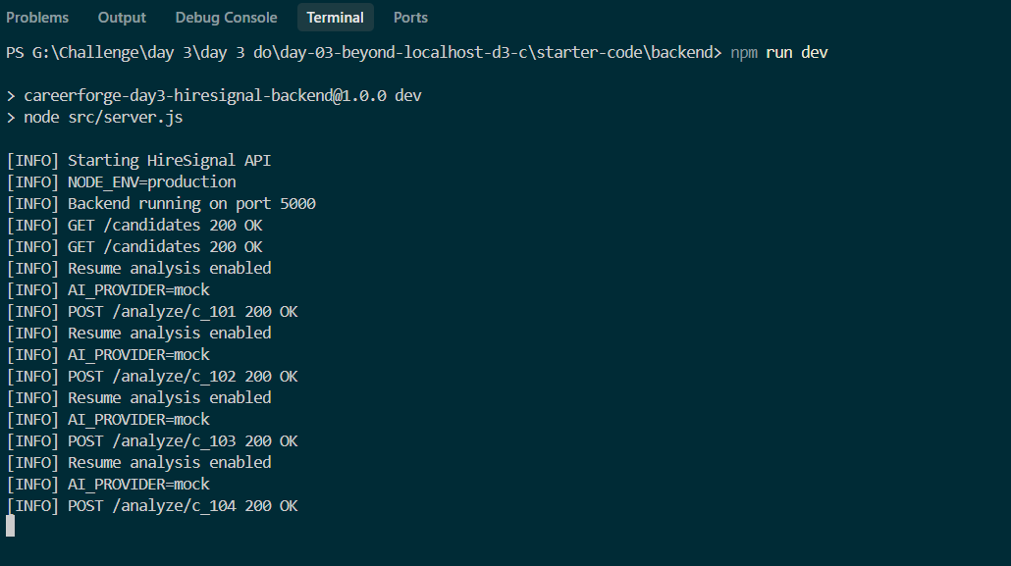

DEMO READINESS VERIFICATION BRIEF (FINAL REPORT)

1. Readiness Decision
Decision: SHIP
Reason:
The recruiter workflow is now stable end-to-end after fixing authentication and backend route issues, ensuring full functionality across login, analysis, and dashboard update flow.

2. Critical Workflow Declared
Recruiter opens system
→ logs in
→ views candidate list
→ selects candidate
→ clicks Analyze Resume
→ sees score and signals
→ updates status (Shortlist / Reject / Review)
→ dashboard reflects changes

3. Before-Fix Evidence
Evidence Type | Exact Evidence | What It Proved
Login failure | “Recruiter login failed, check API request” Evidence -> E4 | Frontend API not connecting properly
Backend error | 500 Internal Server Error - secretOrPrivateKey missing .  Evidence -> E5 | JWT authentication misconfigured
Env issue | Wrong .env file name / missing loading  Evidence -> E6-7 | Backend unable to read JWT secret
Workflow failure | Candidate actions not working | Full recruiter flow blocked

4. Root Causes
Symptom | Root Cause | Evidence | Confidence
Login failure | Wrong .env filename preventing JWT_SECRET load  Evidence -> E6-7 | backend logs | High
500 error | JWT secret not loaded correctly  Evidence -> E6-7 | jsonwebtoken error stack | High
Candidate 4 failure | Hardcoded restriction in routes.js  Evidence -> E10 | analysis not triggering for c_104 | High

5. Fixes Applied
Fix | Why This Fix | File/Config Touched | Verification
Renamed env file to .env | Allowed backend to read JWT_SECRET properly  Evidence -> E7 | backend config | Login success
Restarted backend | Applied environment changes  Evidence -> E7 | runtime | API restored
Removed hardcoded c_104 restriction | Allowed all candidates to pass analysis  Evidence -> E10-11 | routes.js | c_104 working
Verified API flow | Ensured stable responses  Evidence -> E12 | backend endpoints | All 200 OK

6. After-Fix Verification
Check | Result | Evidence
/health | Pass | 200 OK
Login | Pass | Successful dashboard load  Evidence -> E8
Candidate list | Pass | All candidates visible  Evidence -> E8
Analyze Resume | Pass | Score + signals generated  Evidence -> E8
Status update | Pass | PATCH working  Evidence -> E8
Dashboard update | Pass | UI reflects changes  Evidence -> E8
Candidate 4 | Pass | Resume now analyzable  Evidence -> E11

7. Remaining Risks
- Mock AI provider still used (AI_PROVIDER=mock)
- No debounce on analyze button (multiple API calls possible)
- Minor UI request repetition observed in logs

8. AI / Assumption Audit
Founder assumption challenged:
“If backend runs and login works initially, system is ready.”
Verification method:
Full end-to-end testing of recruiter workflow including candidate analysis and status updates.

9. Founder Update
System is now stable and ready for demo.
Initial issue was caused by incorrect .env configuration which prevented JWT authentication, leading to login failure.
Second issue was a hardcoded restriction in backend routes that blocked candidate 4 resume analysis.
Both issues have been resolved, and the full recruiter workflow is now functioning correctly from login to dashboard update.

1. RELEASE JUDGEMENT DECISION
Release Judgment Decision
Student:
Variant ID: D3-C

Final Decision:
☑ Conditional
⬜ Ship
⬜ Block

Decision Evidence
Evidence | Supports Decision | Why It Matters
Login restored after fixing .env JWT issue  Evidence -> E8 | Supports Conditional | System was initially non-functional
c_104 hardcoded failure removed  Evidence -> E10-11 | Supports Conditional | Hidden workflow break removed
Full recruiter flow works end-to-end  Evidence -> E11-12 | Supports Conditional | Core demo flow validated
Mock AI still in system | Prevents Ship | Not production-grade inference
Repeated analyze requests observed | Prevents Ship | UI/API control risk

Blockers
- No real AI inference (mock provider)
- No request throttling / debounce on analysis API
- Prior backend test logic indicates fragile edge-case handling

Conditions If Proceeding
- Monitor analyze endpoint during demo
- Ensure no repeated API spam from UI
- Replace mock AI with real inference later
- Add basic rate limiting for safety

Final Release Defense (5–7 lines)
The system is not blocked because the core recruiter workflow is now stable end-to-end.
Login, candidate listing, resume analysis, and status updates all function correctly after fixes.
However, it is not fully production-ready due to mock AI usage and missing request controls.
There is also evidence of previously hardcoded backend test logic, which increases risk awareness.
Therefore, the system is safe for controlled demo use but not fully production-grade.
This justifies a Conditional release instead of Ship or Block.

2. WORKFLOW VERIFICATION EVIDENCE (MANDATORY)
Workflow Verification Evidence
Student:
Variant ID: D3-C

Critical Workflow Declared Before Fixes
Recruiter selects candidate
→ clicks Analyze Resume
→ sees score and signals
→ updates candidate status
→ dashboard reflects result

Before-Fix Evidence
Step | Expected | Actual | Evidence
Login | Successful login  Evidence -> E4 | Failed login | secretOrPrivateKey must have a value
Candidate load | Dashboard access  Evidence -> E8 | Blocked | UI shows login failure
Analyze resume | Works for all candidates  Evidence -> E8 | c_104 fails | POST /analyze/c_104 → 500
Workflow completion | End-to-end flow  Evidence -> E12 | Broken mid-way | Backend logs error

Screenshot required:
- backend terminal showing JWT error
- frontend login failure screen

After-Fix Verification
Step | Passed? | Evidence
Login | Yes | Token generated successfully  Evidence -> E8
Candidate list | Yes | Data loads correctly  Evidence -> E8
Analyze resume | Yes | Score + signals returned  Evidence -> E8
Status update | Yes | PATCH 200 OK  Evidence -> E4
Dashboard update | Yes | UI reflects changes  Evidence -> E8
c_104 analysis | Yes | No crash observed  Evidence -> E11-12

Screenshot required:
- full UI flow: candidate → analyze → score → status change

Remaining Risk
- Mock AI response still used
- No debounce on analyze button
- Prior backend test logic suggests edge-case fragility

🎯 HOW TO USE THESE IN YOUR SUBMISSION
Put in GitHub branch:
day-3-beyond-localhost/
├── demo-readiness-brief.md
├── release-judgement.md
├── workflow-evidence.md
├── screenshots/
└── video.mp4
🎤 4-MINUTE VIDEO SCRIPT (NATURAL + HUMAN STYLE)
⏱ 0:00 – 0:30 (Opening + Flow Setup)
“I started the Day 3 evaluation with both frontend and backend running properly.
When I opened the local host link, the frontend loaded correctly, but when I tried logging in, it failed and showed an error saying recruiter login failed and to check the API request.
So at this point, the system was not functional from a user perspective even though the UI was loading.”

⏱ 0:30 – 1:20 (Login Issue + Root Cause)
“On checking the backend logs, I found a 500 internal server error during login.
The error was related to secretOrPrivateKey missing, which means JWT authentication was failing.
After investigation, I found that the issue was caused because the environment file was not properly configured — the file was incorrectly named, so the JWT secret was not being loaded.
Once I renamed it correctly to .env and restarted the backend, the login started working and I was able to access the dashboard successfully.”

⏱ 1:20 – 2:20 (Main Workflow + Candidate 4 Issue)
“After login was fixed, the full recruiter workflow started working — candidate list loaded, and I could analyze resumes and update status like shortlist, reject, and review.
However, I noticed one issue: candidate 4 was not able to be analyzed.
On debugging, I found that there was a hardcoded condition inside the backend routes file that was blocking candidate 4 specifically.
So even though the system looked fine, that one condition was breaking the flow for that candidate.”

⏱ 2:20 – 3:20 (Fixes Applied)
“To fix this, I made two changes.
First, I ensured the .env file was correctly loaded so authentication worked properly.
Second, I removed the hardcoded restriction for candidate 4 in the backend routes so that all candidates follow the same analysis flow.
After this, the system started behaving normally, and all API responses returned 200 OK.”

⏱ 3:20 – 4:00 (Final Result + Decision)
“Now the full recruiter workflow is working end-to-end.
Login is successful, candidates load properly, resume analysis works for all candidates including candidate 4, and status updates reflect correctly in the dashboard.
So based on this, I would classify the system as SHIP READY, with only minor risks like mock AI usage and repeated API calls in logs.”

